**Chapter I**

**INTRODUCTION**

Our generation today is highly engaged in an automated technology for having an efficient work inside and outside the business or the student. Technology can be the knowledge of techniques, process and it can be embedded in a machine to allow operating without detailed knowledge of their work.

The advancement of technology gives efficiency and reliability to the user and it gives them the fastest and easiest way of managing and monitoring transaction in every transaction. In these changes it gives a big impact in the society by making all the transaction easy. Taking and managing the system is not easy to handle because it’s your responsibility to maintain and secure all the data given.

Technology gives a big lift in our daily lives and we use various technology to accomplish specific task. Today we have a various technologies that help developing our system to work. Believe that it is smarter of time when out neurological limits, that lead the forgetfulness and oversight, well be supported by complex information system to make our lives and brains more efficient. With such progress in sight, it is enough to assume that our conversation will finally liberate from hasty generalization and biases.

Using a manual system of inventory and managing is a hard time on finding necessary data to acquire specific information. Sometimes it will also leads in confusion, it also consume much time to assess the transaction of the clients and in terms of security, the data are not guaranteed secured in a physical storage.

**Purpose and Description**

The goal of Binalbagan Social Welfare Help Desk is move to current AICS system from Manual system that is prone to any errors, losing of file, Data and have efficiency to a faster and automated system. Through this system the Admin and the Person in Charge can make the transaction easier and faster. The person can update all the data in a shorter time of processing. Using this system the person in charge can automatically search those data that they want to access.

This proposed system is address all the problem found in the existing system. This system will provide the Person in Charge as well as to the clients in easier and faster way of transaction. This system also keep the important record and information of every client, as well as the recording of laboratory status, Financial Assistance, food and medicine to the data base. This system also help to the person in Charge to minimize using paper and pen in every transaction that cause a large time to finish.

This system using technology to make the transaction more computerized and advance. This system also cannot cost a big amount of money the system can help Admin, and also the clients in many ways of transaction. It creates faster work, and less errors. The system requires much less maintenance, which will help to reduce cost of that system. The new system also provides new features which help to obtain information that was not possible before. This system will improve the Binalbagan Social Welfare help Disk System.

**OBJECTIVES OF THE STUDY:**

**General Objectives**

The main purpose of this study is to provide a good service to the person in charge as well as to the clients involve in the society and develop a high standard computerized transaction for easy access to anyone and manage all the transaction. This system can record all the information given by the client. It also detect the outgoing and ongoing transaction and also detect the problem if there is no assistance available and if the clients exceed the normal term of asking the assistance. This study can encode all the assistance provided to the client.

**Specific Objectives**

1. The study of Binalbagan Social Welfare Help Desk System aims to achieve the following:

* To record the number of person who avail the benefits.
* To record the stock of medicine, food, burial, financial and transportation.
* To gather the information of every person.
* To evaluate the people belong in the society.

1. To evaluate the developed system in terms of:
2. Functionality
3. Efficiency
4. Security
5. Accuracy
6. Suitability

**Scope and Limitation**

The scope of this system is for recording, checking and updating data given by the client as well as to monitor the all the information recorded. This system can help the person in charge to make their work easier and more faster. The proponent implement this system to make their manual system computerized and advance also to upgrade their system. As a proponent we provide this system to the MSWDO for easy to them to manage their work and they can keep their file in safe.

The limitation of Social Welfare Help Desk System doesn’t support online transaction. Creating a backup facility of the system and updating every record of the client. The client must have their ID in every transaction so that they can avail a financial assistance from the office. Viewing of history of every transaction based on the date where the clients ask an assistance and also the inventory report for every transaction is at the end of the year.

**Significance of the Study**

The Binalbagan Social Welfare Help Desk System is intended for their transaction processes. The following are the significance of the study.

1. **Client:** The client can benefit in this system because they can access or avail the assistance from Binalbagan Social Welfare Help Desk System.
2. **Person in Charge:** Help to disseminate and manage all the transaction provided by the Binalbagan Social Welfare Help desk.
3. **Future Researcher:** This well serve as reference to the future researcher if they will innovate this study. This also give them a knowledge in creating and developing the system.

**Definition of Terms**

1. **Clients-** in dictionary: a person who engages the professional advice or services of another.

In this study, term was use which the client is the person who have transaction in the person in charge, or those patient who need a financial assistance from the person in charge

1. **Municipal Social Welfare Development Office-** the institution need to use a developed automated system.

In this study, term was use of the Municipal Social Welfare and Development Officer (MSWDO) assist children and youth whose basic needs have been deliberately unattended by their parents or guardians, or have been victim of any form of child abuse and provide assistance to individuals and families who are victims of natural and man-made calamities such as typhoons, floods and fire.

1. **Person in Charge-** it refersto a person who controls the use of something or to manage the organization. It refers a person in charge the one that disseminate or accommodates the clients regarding to their transaction. It refers to a person who have knowledge to operate the system and manage the client’s transaction.

In this study, term was use of the person who has the overall responsibility for running that Location during the entire time of operation. If there are multiple shifts, the Person In Charge will be responsible for the proper functioning of the food establishment’s operation during the work shift.

1. **System-** Itreferstoa coordinate body of methods or a scheme or plan of procedure organizational scheme. It refers to help the transaction easy to manage and disseminate transaction in every clients.
2. **Transaction-** It refers is an agreement or contract that involves by the two or more persons and parties establishes obligation of both parties. It refers to the one that done by the clients.

  In this study, term was use to a transaction is an exchange of goods, service, and communication between two sides that has an effect on each side. In the simplest case, a conversation between you and a friend is a transaction. You exchange information, and both of you are affected by the exchange.

**Chapter II**

**Review of Related Literature**

**Background of the Study**

BSWHD is one of the organization in the municipality that provide or help the people in their crisis situation one that gives financial support and any kind of the said help. To have a good service, In this situation the client is evolve to have highly computerized system so that they can perform a good efficient service, less time and fastest to accommodate their clients in a short time.

The in charge of BSWHD is highly aimed to have a computerized system for easy to them to list down their record , update their work , and make their inventory more faster and take a less time to finish their work. The help of this computerized system they can manage all the needs and aspect of the said transaction like recording, listing of medical receipt giving of medicine, giving of financial support, cash assistance to the member of the society.

**Review of Related Literature of System**

This chapter deals with a review of publication and investigation related to present study that is related to out proposed system. By the use of this study we can easily understand other and develop a more advanced and effective system for the BSWHD system.

**Foreign Related Literature**

**Record Inventory Management System**

According to Thomas M. McHugh (2014) computerized inventory management systems provide many benefits that are hard to obtain using paper methods or an in-house spreadsheet. Systems that are specific to the lab can be used relatively quickly without a significant learning curve or system customization. The ability to analyse the inventory, item usage, purchasing history, and the areas (e.g., lot numbers, equipment) are important improvements to spreadsheet and paper systems. If the system includes equipment tracking, it can be used to determine the capital asset as well as track the service history and lifespan or equipment. The ability to streamline and automate many of the inventory control tasks will be increasingly important to reduce hands-on time while improving the analysis of trends, reducing stock-outs, and avoiding expiring reagents in the right quantity is present at the right time is critical to laboratory operations. Given that reagents are approximately one-half of most labs’ operating budgets, a continued focus on this expense will assist the laboratory in continuing to provide accurate and timely laboratory testing ate the lowest cost.

**Foreign Prior Arts**

**Impact of Retirements and Pensions on the Social Welfare of the  
Households from Minas Gerais State**

According to Calazans, Souza, Hirano, Caldeira, Silva, Rochaand Caetano (2013, ) Social security systems are an important area of public policy and social spending and produce direct or indirect effects on all members of society (Lee & Chang, 2006). In addition to their function as social insurance, public social security systems play an important role as income distribution mechanisms (Diamond, 1977). In this regard, the analysis of the socioeconomic impact of social security systems is the focus of numerous studies published in the international literature, including Bellettini and Ceroni (1999), Guillemard (1999), Arza (2006), Lee and Chang (2006), Clement (2007) and Goudswaard and Caminada (2010). In Brazil, social security has been an important public policy tool in the social arena since the 1930s. Its main purpose is to guarantee the income of workers and their families in the event a worker loses the ability to work. The Brazilian social security system is one of simple redistribution (pay-as-you-go, or PAYG) that is similar to systems in countries such as Germany, France, Japan and the United States.

Regarding RPPS, more than 8million people, including public servants and active, inactive and retired military personnel, are afliated with one of the 2,236 RPPS existing in the country.” Together, the RGPS and RPPS have more than 49.6 million members, which represents 53.5% of the employed, economically active population (Lima, Wilbert, Pereira, & Paulo, 2012). Regarding the pervasiveness of Brazilian social security, retirement and pensions account for a notable share of the total income of Brazilian families. Daré and Ho fmann (2012) examined data from the National Household Sample Survey (Pesquisa Nacional por Amostra de Domicí-lios – PNAD) and found that income from retirement and pensions accounted for a significant portion of declared income; specifically, income from pensions represented 20.3% of total household income in 2009. The literature has recognized that social security is a major social policy tool in Brazil, and studies have placed particular emphasis on social security’s distributional aspects; on its impact on the goals of poverty reduction and the alleviation of income distribution inequality; and on its e fects on the economy of small municipalities.

**Assessing social welfare department service delivery system towards vulnerable and disadvantages group in Malaysia**

According toMariana Mohamed Osmana, Nurul Izzati M Bakrib, Syahriah Bachokc Mansor Ibrahimd, Mohd Zin Mohamede (2015), Sustainability stresses on the longevity of social well-being of all fellows of the community including health, education, social interaction, recreational, religious freedom and cultural-value or beliefs expression, among others. Currently, many initiatives at all levels intended to increase the opportunities for these vulnerable and disadvantaged groups to participate in the collective activities of the community have been took places. Their impact in terms of outcomes is less than satisfactory. Hence, these groups were continued being excluded from the society and faced real difficulties in accessing employment, education, housing, and public spaces and facilities.

Social equality and equal opportunity for all has emerged as the key component of social sustainability for majority developed countries. Realization on the important of social equality and equal opportunity for all, especially to the disabled, the vulnerable and disadvantages groups, the implementation of government delivery services to these groups has become one of the main indicators to measure the effectiveness and efficiency of services delivered and offered by the government. Although in most developing countries, improving the quality of government delivery system is quite a challenge, awareness towards social rights of these fewer fortunate groups needs to be promoted. With this intention, joint effort has been initiated by the policy and decision makers, with the support and help from the developers and operators in ensuring the vulnerable and disadvantaged group receive maximum quality of life. This research highlights varied demographic characteristics of the vulnerable and disadvantaged group of people in Perak as well as the service delivery performances rendered to them.

**Local Related Literature**

**Inventory System**

According to the study of Christian Bernese, Jayce Marin, Regie Millan, and Heavenlyn Porcado (2013), Inventory System is a specific implementation of an inventory service and it is used to plan and track inventory balances and activities. Inventory is basically the total amount, number of stocks and records of supply or materials of a store and other business. Philippine Computer Company (PhilCom) is specialized in buying and selling computer parts and offers brand new and second hand computer materials. They also offer computer services like computer check-up, assembling and formatting. Point of Sale (POS) is an electronic system designed to help business maintain and analyze inventory and transaction occurs in exchange for goods and services.

Inventory System is somewhat similar to the proposed system that also aims to have a secured data and to designed a system that would help to make an easy way of calculating the number of stocks and the total amount or number they used. To help business maintain, analyze inventory and transaction data on a continuous basis. It helps the system to review the stored data.

**Local Prior Arts**

**Determinants of Social Insurance Coverage in the Philippines**

According to Ma. Belinda S. Mandigma(2016), The study analyzed the coverage of the most dominant form of social security which is social insurance or public pension in the Philippines by examining the relationships with selected key economic and non-economic variables. Aggregated panel data for the period 2000-2013 were tested using Generalized Linear Model, Multivariate Ordinary Least Squares, Fixed effects & Random Effects and Generalized Method of Moments. Results revealed that coverage represented by contributors from the economically active population are influenced only by some economic variables like economic stability, capital formation, wage growth and urbanization, economic development and globalization. Coverage corresponding to the elderly beneficiaries is also affected by the foregoing economic factors except for globalization, but inclusive of national administrative capacity, employment and unemployment. Further, non-economic drivers of elderly coverage are feminist theory, education, informal sectors and poverty incidence. More statistically significant determinants for the elderly confirms the conclusion of Rofman and Oliveri (2012) that assessing coverage among the elderly presents fewer difficulties, since instead of measuring the accumulation of potential rights, the focus is on the proportion of eligible individuals who are currently receiving benefits.

**Chapter III**

**Design and Methodology**

In this chapter present about the research methodology for hoe the system will be develop by gathering information to serve as the foundation of the system, the discussion about analysis and planning, developing the design of the system, the structure, lastly the testing and the deployment of the system.

**System Development Life Cycle**

The System Development Life Cycle (SDLC) is a conceptual model used to know the system requirements in hardware and software that window can adopt. This may also help us to know what are the procedures that are going to use in developing our system. Design and Methodology stress the use of brainstorming to come with the idea and arrive at the best solution. The main concern of design and Methodology are the needs and wants of the user

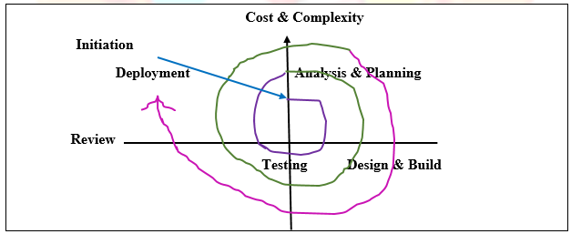

*Figure 1: Spiral Model*

Figure 1 Shows the Spiral Model Diagram used by the proponents as their model for the system. It shows how the research and process is being develop from the start of the process until it has been finished , Spiral Model is easy to be use because as you can see from the diagram it has been process step by step so that the problem that might encountered can be polished by reviewing every step. In Spiral Model the function are develop as the prototype is being integrated to make the complete process quicker, it makes it easier to incorporate and understand the changes within the development. The advantage of Spiral Model from the other phase is the project monitoring is easy and effective. Each phase, as well each loop, requires a review from concerned people. This make the model transparent.

**Initiation**

The proponents conduct series of interview to the MSWDO of Binalbagan and observe their current system Functionality and also conduct interview to the employee in charge. In this phase the proponents need to gather data, determined the problem cost and consider the needs of the clients.

**Analysis and Planning**

With the data gathered from the interviews and researches conducted the proponents were going to use this data to provide solution to the problem that has been discovered. With the information gathered, now discuss how the system will work.

**Design and Build**

In this phase, the proponents now use the information gathered to create efficient and user friendly interface. By the use if development tools were going to start to create the structure and function of the system

.

**Testing**

This phase involve the testing if the system if it is ready functional and meet the desired requirements of the end user and proponents test the system a beta testing.

**Deployment**

After the testing, the deployment of the system follows, in this phase the new created system well be installed in the production process. The user will be trained or will be guided in how the system works. The system will be give the client and the processes will be evaluated.

**Cost and Complexity**

As the proponents gather all the information the proponent needed to develop the proposed system , the proponents give time and effort to the development of the system so that they can acquired the necessary information and cost to use some money to give the system development more accurate to desired need of the end – user.

**Use case Description**

|  |  |
| --- | --- |
| Use Case  Name: | Login |
| Actors: | Person in |
| Description: | This use case describe the person in charge to log and to check the information |
| Pre-conditions: | The person in charge ask information from the client |
| Post-conditions: | The person in charge need to log in to check all the data given by the client |
| Normal Flows: | 1.The person in charge can access the client through checking the information given  2.The person in charge successfully log in |
| Alternative Flows: | If the system error back to log in form. If it is success proceed to next. |

*Figure 2: Use case Diagram of Log in*

Figure 2 Show the log in side of the admin the person in charge need to log in to check all the data and information from the client.

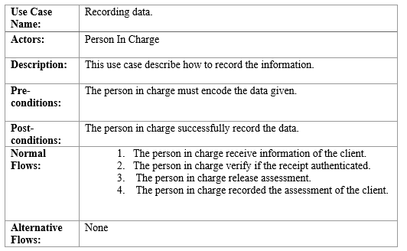

*Figure 3: Use Case Description of Recording Data*

Figure 3 show the Use Case Description of Recording data of the client. Where in the person in charge encode all the data given by the client.

**Data Flow Diagram**

Figure 2. Data flow Diagram of the proposed solution shows all the concept and flows of each entities and process of the proposed system. Solution showing this flows may help the reader to identify which the process begins.

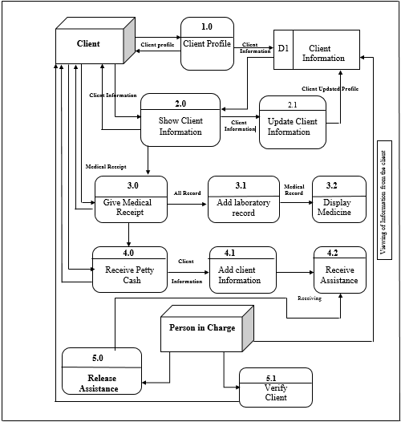

*Figure 4: Data Flow Diagram*

**Use Case Diagram**

The Use Case Diagram Shows the action done by doing the process of the system. It illustrate the work of the user and each function.

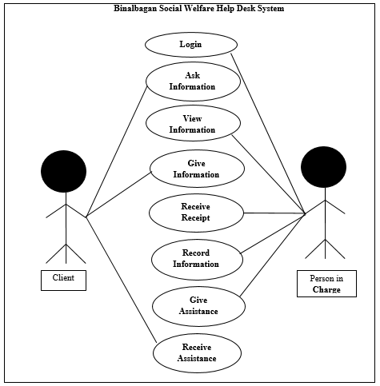

*Figure 5: Use Case Diagram*

**Actors:** Person in Charge, Clients

**Person in Charge**: The person in charge has a capability to check or evaluate their clients first in terms of medical or asking of medicine the clients must ask a medicine once in a month only. If the clients exceed the normal term of asking the medicine or any assistance they need to provide a letter so that they can avail again.

**Clients:** clients can ask any information from the office to avail any assistance but make sure that the purpose of asking some assistance is for good intention in order to avail the medical assistance the clients must show their hospital receipt or heath card from the hospital.

**Activity Diagram:**

The figure below shows the Activity Diagram of Binalbagan Social Welfare Help Desk System Create Login Button.

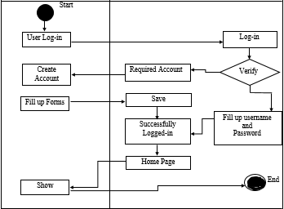

*Figure 6: Activity Diagram User Log in*

Figure 6 shows the Execution of the activity login button in Binalbagan Social Welfare Help Desk System. The Admin must Create the account then the admin must click the log in button;. The system well click the database. If the system confirms the user and the password , it show the dialog whether he or she successfully log in or it display an error message or information during login process.

This is the Activity Diagram of Binalbagan Social Help Desk system for Add New Client,

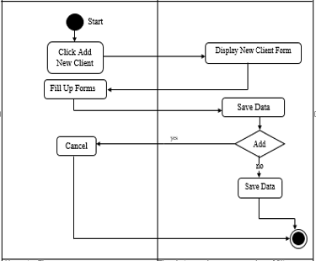

*Figure 7: Activity Diagram of Add New Client*

Figure 7 show the execution of the system. The user will click the add new client button then the system will display the new Client Form and the user will input the information needed. All the information will be save on the data base

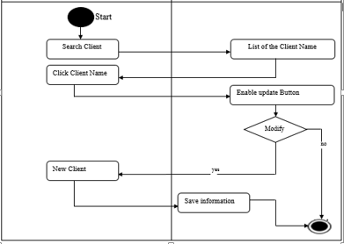 This Study is the Activity Diagram of Binalbagan Social welfare Help Desk System for update account button.

*Figure 8: Activity Diagram for Update Client*

Figure 8 show the execution of update table. The user will search the name of the client then the user must click the update button to execute the data.

**Decomposition Diagram**

Decomposition Diagram is a generalized diagramming technique that can be used to supplement the formalized structure analysis and design methodologies in a variety of ways.

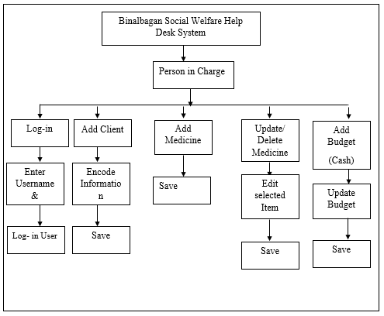

*Figure 9: Decomposition Diagram*

Figure 9 shows the Decomposition Diagram of Binalbagan Social Welfare Help Desk System for Municipality of Binalbagan. The Decomposition chart categorized by the admin. Authentication module involves in logging in all users in the system. The admin will focusing in adding client, updating, and giving of assistance. It start from the high level process down to sub process.

**Conceptual framework**

As every Step is done, the proponents review the information, inputs and the processes in the proposed system, for us to know that we could change remove or add certain functionality or feature.

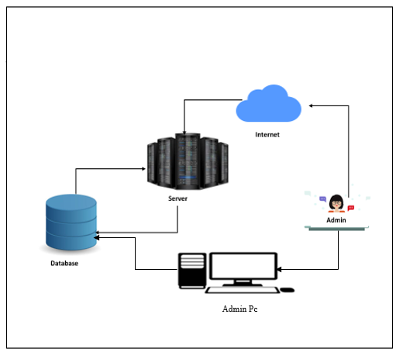

*Figure 10: Conceptual Framework*

Figure 10 shows the Conceptual framework of the system was composed of a Database and Admin PC. The Admin PC updates the information of the clients stored in the database as well the system, configuration. The information inside the database will return to the Admin PC.

**Recommended Hardware Specification**

This system run in a perfect function by using this Hardware specification.

* Processor : Intel Core i5 Equivalent
* RAM : 2 GB DDR3
* Hard Disk : 500 GB of free disk Free
* Monitor : 32 inches
* Resolution : 1366x768
* Keyboard : Standard PS/2 Keyboard
* Mouse PS/2 Compatible Mouse

**Recommended Software Specification**

* Microsoft Windows 10 64bit
* MySQL
* HeidiSQL

**Data Dictionaries**

The table shows the list of the conceptual databases on the computerized inventory system for Binalbagan Social Welfare Help Desk. It provides the attributes, data types and also description for each field name so that the information will ensured to capture by the database.

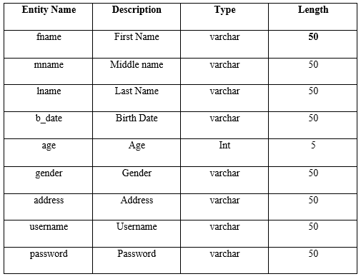

\

*Table 2: Admin Table*

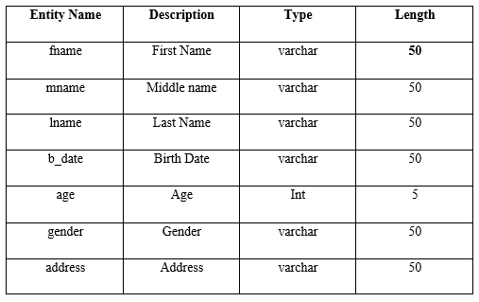

*Table 3: Client Table*

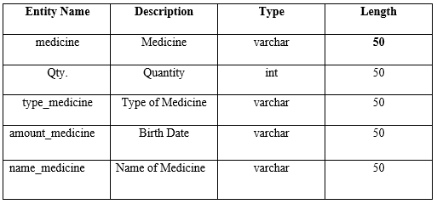

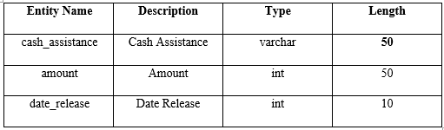*Table 4: Medical Assistance Table*

*Table 5: cash Assistance Table*

***Entity Relationship Diagram***

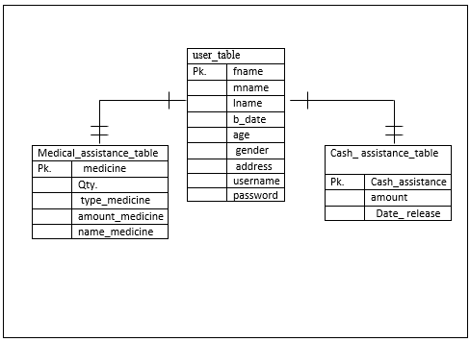

*Figure 11: Entity Relationship diagram*

ERD OR Entity Relationship Diagram show the relationship of tables in the database. Figure 11: Entity Relationship Diagram show the connection of each table. The created database models were based on the specification of the system requirements or it means that the tables that have been created from the database of Binalbagan Social Welfare Help Desk System is define using SQL language; it keeps the record totally safe.

Data Management System designs the interface of the program that will manage the processing of the database and the tables that are being designed Data Dictionaries.

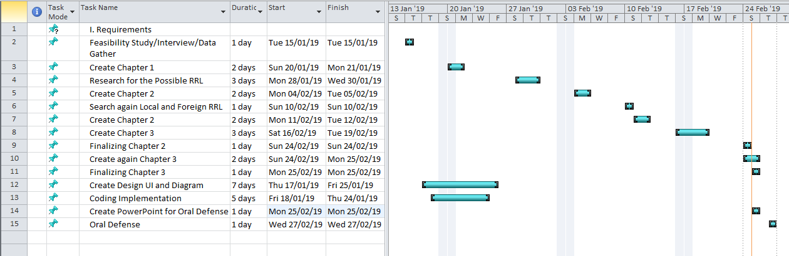

*Figure 12: Gant Chart*

Figure 12 shows the amount of work done or production completed in a certain period of time in a relation to the amount planed for those periods.

Gantt chart describes the overall activities in developing the system and application. This chart guides the proponent to managed time by recording the event occur during and after the process. This chart shows the measurement of length or how long it takes when doing the process of the system and application. By this Gantt chart, it is easy to figured out the delivery time of the proposed project.

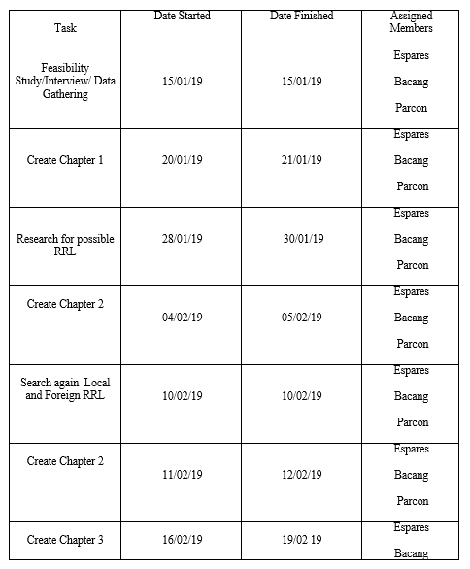 Time Table

The time Table shows the task by the proponents.

